**Hit and Run Car Accidents In NYC**

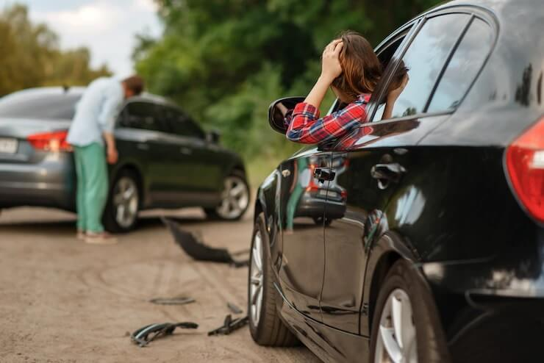

Hit and run incidents are common in New York and across the world. A hit and run automobile accident is defined as when a car driver hits someone or something, or is engaged in a crash, and does not stop after hitting. It is a natural human reaction to grow anxious and attempt to flee the situation; nevertheless, there are additional factors that push the individual to flee. Some people flee due to trauma, while others do so due to a lack of finances and insurance money.

Hit-and-run automobile accidents now have very significant consequences. In New York, it is a significant crime. A clear understanding of the rules governing hit-and-run vehicle accidents in New York City may help you avoid panic and terror, and give you the energy and determination to protect yourself and be courageous in this scenario.

What urgent actions should we take in the aftermath of **NYC car accidents today**?

When this sad event occurs, here are some suggestions on what you should do.

1. Stop and be calm right away and regain control of your senses. These types of things, I believe, happen unintentionally. Then get out of your automobile and run over to the place to see if everything is in order. Is there anyone hurt? OR is there any form of damage? If there is, see if they require any assistance.

2. Exchange contact and insurance information.

3. Call 911 or the local police station if someone is injured, dies, or if there is property damage worth more than $1400. Stay still until the cops arrive, then file a report.

Two enactments that require a person to perform them during car accidents are protected by the **NYC traffic rules** and vehicles legislation.

If an accident occurs without any injuries or deaths, but just vandalism is involved, and the cost of destruction exceeds $1400, you must exchange your license and insurance information with other driver. If no one is hurt or killed, police intervention is not required. VTL 600-1a is the law in question.

2. If there are any injuries or deaths as a result of the accident, we must notify the authorities and file a report. Another problem is that a person is physically incapable of filing a report than thats a valid excuse. Regardless of who caused the harm and who is accountable, license and insurance information must be provided. VTL 600-2a is the statute in question.

What if we can't track down the drivers while **driving around NYC**? Involved in the mishap.

If there is property damage in the accident and we are unable to locate the driver, simply leave your contact information and insurance information on a note and tape it to the missing person's car windshield. If you are unable to locate him, your responsibility is to contact the police and **report hit and run NYC** accident.

**NYC Traffic Laws** That Apply to Hit-and-Run Cases

In New York, the laws against hit-and-run are nearly impenetrable. And if someone makes a mistake, he or she will be subjected to severe sanctions. The best option is to engage a lawyer who is familiar with the system, the legislation, and the methods for recovering your due compensation and the amount that your insurance company is required to pay you. If the driver has escaped, the lawyer can assist you in tracking him down, but keep in mind that the case must be new in order for evidence to be fresh, witnesses to be present, and the driver to be discovered fast.

**Punishment for Hit and Run Case**

You will risk serious sanctions if you abruptly leave the accident scene before providing the other motorist with your contact information and insurance information. You must use extreme caution. If you have any doubts that you may have impacted anything or an [automobile](https://cheaptowingnyc.com/), pull over immediately and look for any damage or injury caused by your vehicle to another person.

According to **NYC traffic laws**, no one can leave an accident scene until both drivers have exchanged information with the other. If they fail to do so, i.e., if they purposely flee or hide somewhere, New York traffic law will consider it a hit and run, which is a severe conduct and a felony, regardless of the damage. Leaving a minor collision or striking a parked car is Unlawful.

If you are apprehended by NYC law enforcement and must pay **NYC traffic fines**, If you leave the scene of an accident, you might be fined up to $200 plus court costs and other fines separately, or you could spend up to 10 days in jail, receive 3 points on your driving record, and see an increase in your vehicle insurance premiums.

**Common Traffic Mistakes** Following a Hit-and-Run

The following are the most typical hit-and-run mistakes:

• Not filing a police report.

• Not filing a claim with the insurance company.

• Ignoring medical advice and presuming you're sick.

• Believing that the insurance provider will assist you in getting your money.

• Using an inexperienced attorney.

How Can Hit-and-Run **Accident Lawyers NYC** Assist You?

The benefits of choosing an accident lawyer include years of expertise and a proven track record of successful settlements, as well as the highest likelihood of achieving a win-win situation in court. They may assist you by:

• Filing the complaint together with all supporting documents in accordance with New York deadlines and court requirements.

• Attempting to locate and track down the fugitive driver.

* Obtaining information about the missing driver through questioning and interrogating neighbors, bystanders, police officers, and first-person witnesses in the vicinity.
* They collect evidence in the form of traffic camera films, police ambulances, and medical evidence reports, among other things.
* Lawyers might also enlist the assistance of private detectives.
* Making arrangements with the insurance company's lawyers for a meeting. Because New York has a no-fault insurance statute, your insurance company is responsible for all expenses, damage charges, [transportation](https://rapidnyctowing.com/), and lost earnings if you are harmed. If you can't locate a driver or if he doesn't have insurance, your uninsured motorist personal injury insurance will help you pay for your medical bills for your pain and suffering. The insurance company will want to settle you for the little amount you can discreetly collect for them, but it is your lawyer's obligation to know all of the strategies and be prepared to fight for a fair settlement on your behalf.
* If your matter goes to trial, your attorney will argue and control your position in front of the jury.